**Cancer Prediction Using Graph Database**

**Abstract.** This research paper aims to provide a comprehensive overview of cancer cases and rates in the various states of the United States. It explores the trends and patterns of cancer incidence and mortality in the country, as well as the factors such as age, sex/gender, type of cancer whether it is lung or breast cancer and its rates and also the factors that contribute to the development and progression of the disease. The paper reviews the latest statistics on cancer rates mainly breast and lung cancer in different population groups, including age, sex/gender, and geographical location/different states of USA.  By analyzing the data, the project aims to provide insights and predictions related to the occurrence of cancer in the US. The Python code implements visualizations of cancer data for various states in the USA using Pandas and Matplotlib libraries. The dataset is read into a Pandas data frame and various types of visualizations are produced for the cancer data, including scatter plots, and bar graphs. The scatter plot represents the rate of lung and breast cancer in various states of the USA, and the bar graphs represent the total number of breast cancer and lung cancer, as well as the cancer rates in people of different age groups for each state. The visualizations allow for the comparison of cancer rates and total numbers between different states and age groups, aiding in identifying the states with higher cancer rates and potentially identifying any trends or patterns. The paper concludes by discussing the challenges and opportunities for cancer prevention, early detection, and treatment in the United States, and the implications for public health policy and practice. Potential applications of this analysis include informing strategies for cancer prevention and treatment in different states and age groups. The project could have implications for public health and policy, as well as for advancing our understanding of cancer and its impact on society. Overall, this paper aims to provide a comprehensive and up-to-date picture of the burden of cancer in the United States and to identify areas for further research and action.

**Keywords:** Cancer incidence, mortality, cancer prevention.

**1 Introduction**

**1.1 About Cancer**

Cancer is a complex and life-threatening disease that has become a significant health concern worldwide. It’s a disease in which the human's cells grow out of control and multiply throughout the body. Cancer is a cluster of circumstances in which cells in the body start to reproduce and multiply in an unconstrained manner. The damage may succeed, or may be caused by errors that occur during normal cell regeneration(Bevilacqua et al., 2006). Cancer cells can go to different parts of the body, where they start to multiply and shape new tumors. This is called metastases. It happens when cells enter the bloodstream(Shandilya & Chandankhede, 2018).

**1.2 How common is Cancer**

In the US, Cancer is the second major source of death, holding for nearly one in every four deaths. Cancer incidence and its types are affected by many factors, including age, gender, ethnicity, etc(Rawat & Sah, 2013b). Lung cancer is the most commonly diagnosed cancer in men, followed by oral cavity and laryngeal cancers whereas cervical cancer and breast cancer are most commonly diagnosed in women (Mathur et al., 2023). Therefore, it’s crucial to acknowledge the attributes that help to progress cancer growth and find solutions to predict its occurrence(Da Cruz et al., 2018).

**1.3 Aim of this Project**

Machine learning and data analysis techniques have proven to be effective in identifying patterns and predicting outcomes in various fields, including cancer research(Rawat & Kumar, 2020). In this project, we aim to use machine learning and data analysis techniques to analyze cancer prediction rates in various states of the USA and predict the likelihood of breast and lung cancer development in the future. By analyzing this data, the project aims to provide insights and predictions related to the occurrence of cancer in the US(Bevilacqua et al., 2006; H. Chen et al., 2016).

**2 Methodology of the Project**

**2.1 About the Dataset**

We will use a publicly available dataset (a CSV file) that contains information on the total rates and numbers of breast cancer and lung cancer cases in different states of the US, as well as the cancer rates of different age groups. Using this dataset, we will perform data analysis and visualization techniques to identify any patterns or correlations between the different factors such as age, sex/gender, type of cancer whether it is lung or breast cancer and its rates(Oluyide et al., 2018).

**2.2 Use of Python programming language and its specific libraries in the project**

The project utilizes the pandas library in python to read and manipulate the data and the code also utilizes matplotlib library to create various graphs and visualizations (such as scatter plot and bar graphs) to better understand the trends and patterns in the data. Also the PrettyTable module is used to create a table that maps the full name of each state to its abbreviation(Sah et al., 2020)(Sah, Bhadula, et al., 2018). Specifically, the code creates scatter plots and bar graphs to represent the total rates and numbers of breast cancer and lung cancer cases in different states of the US, as well as the cancer rates of different age groups(Lamine et al., 2017; Rodriguez-Mier et al., 2016).

**2.3 About the project**

The code first creates a dictionary of states and their abbreviations, which is then used to create a pretty table for reference. The code then creates a scatter plot to represent the cancer rates of lung and breast cancer in the states of the USA. The scatter plot uses the state names from the Data Frame on the X-axis and the Total Rate of cancer on the Y-axis. Next, the code creates a bar graph to represent the total number of breast cancer and lung cancer in each state. The bar graph uses the state names from the Data Frame on the X-axis and the Total Number of cancer cases on the Y-axis(Rawat & Sah, 2013a)(Rawat & Sah, 2012).

Following this, four more bar graphs are created to represent the Cancer Rate of people based on different age groups i.e. below the age of 18, between 18-45, between 45-64 , and above 64 for both breast cancer and lung cancer in the various states of the USA(Alshamlan et al., 2015)(Sah, Dumka, et al., 2018).

The visualizations allow for the comparison of cancer rates (Breast and lung) between different states and age groups, aiding in identifying the states with higher cancer rates and potentially identifying any trends or patterns(Sah et al., 2022). Overall, the code aims to analyze and visualize the cancer rates and cases in different states of the USA through different types of plots(J. Chen et al., 2018; Ma et al., 2019).

**2.4 Code Snippet**

import pandas as pdimport matplotlib.pyplot as mplfrom prettytable import PrettyTabledf = pd.read_csv('cancer.csv')from prettytable import PrettyTablestates_dict = { "Alabama": "AL", "Alaska": "AK", "Arizona": "AZ", "Arkansas": "AR", "California": "CA", "Colorado": "CO", "Connecticut": "CT", "Delaware": "DE", "District Of Columbia":"DOC", "Florida": "FL", "Georgia": "GA", "Hawaii": "HI", "Idaho": "ID", "Illinois": "IL", "Indiana": "IN", "Iowa": "IA", "Kansas": "KS", "Kentucky": "KY", "Louisiana": "LA", "Maine": "ME", "Maryland": "MD", "Massachusetts": "MA", "Michigan": "MI", "Minnesota": "MN", "Mississippi": "MS", "Missouri": "MO", "Montana": "MT", "Nebraska": "NE", "Nevada": "NV", "New Hampshire": "NH", "New Jersey": "NJ", "New Mexico": "NM", "New York": "NY", "North Carolina": "NC", "North Dakota": "ND", "Ohio": "OH", "Oklahoma": "OK", "Oregon": "OR", "Pennsylvania": "PA", "Rhode Island": "RI", "South Carolina": "SC", "South Dakota": "SD", "Tennessee": "TN", "Texas": "TX", "Utah": "UT", "Vermont": "VT", "Virginia": "VA", "Washington": "WA", "West Virginia": "WV", "Wisconsin": "WI", "Wyoming": "WY"}table = PrettyTable()table.field_names = ["State", "Abbreviation"]for state, abbr in states_dict.items(): table.add_row([state, abbr])print(table)table2 = PrettyTable()table2.field_names = ["Year", "Total Population", "Total Lung Cancer Cases","Total Breast Cancer Cases", "Cancer Rate"]table2.add_row(["2014", "318386329", "224210", "232670", "143.99"])table2.add_row(["2015", "320738994", "221200", "231840", "141.5"])table2.add_row(["2016", "323071755", "224390", "246660", "145.8"])table2.add_row(["2017", "325122128", "222500", "252710", "146.16"])table2.add_row(["2018", "326838199", "234030", "266120", "153.02"])table2.add_row(["2019", "328329953", "228150", "268600", "151.29"])table2.add_row(["2020", "331501080", "228820", "276480", "156.34"])table2.add_row(["2021", "331893745", "235760", "281550", "155.86"])table2.add_row(["2022", "332403650", "236740", "287850", "157.81"])print(table2)print("To refer the graphs use the table above !")#The rate of Lung and breast cancer in the states of USA using scatter plotmpl.scatter(df['State'], df['Total.Rate'])mpl.xlabel('State')mpl.ylabel('Total Rate')mpl.title('Cancer Rate In various states of USA in a Scatter Graph')mpl.show()#The total number of breast cancer and lung cancer in various states of USA represented in a bar graphmpl.bar(df['State'], df['Total.Number'])mpl.xlabel('State')mpl.ylabel('Total.Number')mpl.title('Total number of breast cancer and lung cancer in various states of USA')mpl.show()#The Cancer Rate of people below the age of 18 of breast cancer and lung cancer in various states of USA represented in a bar graphmpl.bar(df['State'], df['Rates.Age.< 18'])mpl.xlabel('State')mpl.ylabel('Cancer Rates at Age< 18')mpl.title('Cancer Rate of people below the age of 18')mpl.show()#The Cancer Rate of people at the ages of 18-45 of breast cancer and lung cancer in various states of USA represented in a bar graphmpl.bar(df['State'], df['Rates.Age.18-45'])mpl.xlabel('State')mpl.ylabel('Cancer Rates at Ages of 18-45')mpl.title('Cancer Rate of people at the ages of 18-45')mpl.show()#The Cancer Rate of people at the ages of 45-64 of breast cancer and lung cancer in various states of USA represented in a bar graphmpl.bar(df['State'], df['Rates.Age.45-64'])mpl.xlabel('State')mpl.ylabel('Cancer Rates at Ages of 45-64')mpl.title('Cancer Rate of people at the ages of 45-64')mpl.show()#The Cancer Rate of people at the ages above 64 of breast cancer and lung cancer in various states of USA represented in a bar graphmpl.bar(df['State'], df['Rates.Age.> 64'])mpl.xlabel('State')mpl.ylabel('Cancer Rates at Ages above 64')mpl.title('Cancer Rate of people at the ages above 64')mpl.show()df2 =pd.read_csv('cancerrate2014-2022.csv')mpl.plot(df2['Year'], df2['Cancer.Rate'])mpl.xlabel('Year')mpl.ylabel('Cancer Rate')mpl.title('Plot graph showing average increase in Cancer Rate over the years')mpl.show()Usa_cancer_rate_yearwise = { "2007-2013":"190.65", "2014": "143.99", "2015": "141.50", "2016": "145.80", "2017": "146.16", "2018": "153.02", "2019": "151.29", "2020": "156.34", "2021": "155.86", "2022": "157.81",}a = 2.49 #2014-2015b = 4.3 #2015-2016c = 0.36 #2016-2017d = 6.86 #2017-2018e = 1.73 #2018-2019f = 5.05 #2019=2020g = 0.48 #2020-2021h = 1.92 #2021=2022average_2014_2022 = (a+b+c+d+e+f+g+h)/8y = round(average_2014_2022 , 3)print("The average increase in Cancer Rate in USA is" + ' ' + str(y))cr_2023_high = 157.81 + ycr_2023_low = 157.81 - yprint("So in the coming years the change in the rate of cancer is")print('Peak value: ' + ' ' + str(cr_2023_high))print('Least value: ' + ' ' + str(cr_2023_low))

**3 Conclusions**

Based on the project, we can conclude that the cancer incidence varies greatly between states in the USA. The scatter plot shows the overall cancer incidence (breast and lung) for each state, indicating that some states have much higher rates than others. The bar graphs for the total number of breast and lung cancer cases further highlights this variability, with some states having significantly more cases than others whereas the bar graphs for cancer rates at different age groups shows that the incidence rates also vary by age group. States with high rates of cancer overall do not always have high rates in all age groups. This information can be used to identify states with high rates of cancer in specific age groups and aid in targeted public health interventions. Also these visualizations can inform public health policies and interventions aimed at reducing cancer rates and improving access to cancer care and could have implications for public health and policy, as well as for advancing our understanding of cancer and its impact on society.

Overall, this code provides a convenient way to visualize and compare cancer incidence across different states and age groups(Sah, et al., 2023).. It helps identify areas that need more attention and resources related to cancer prevention and treatment.

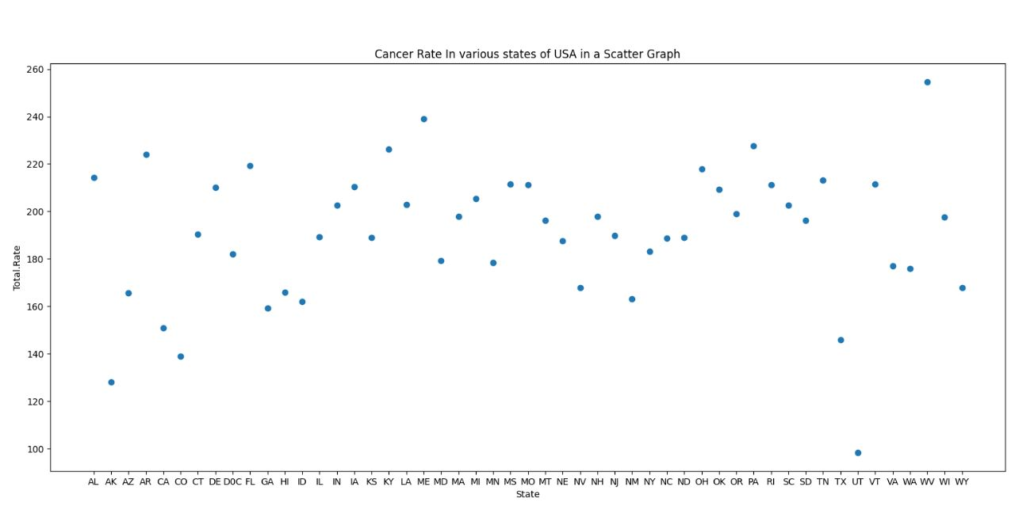

**Fig. 1.** Cancer rates in various states of USA in a Scatter Graph (Generated by MatPlotLib)

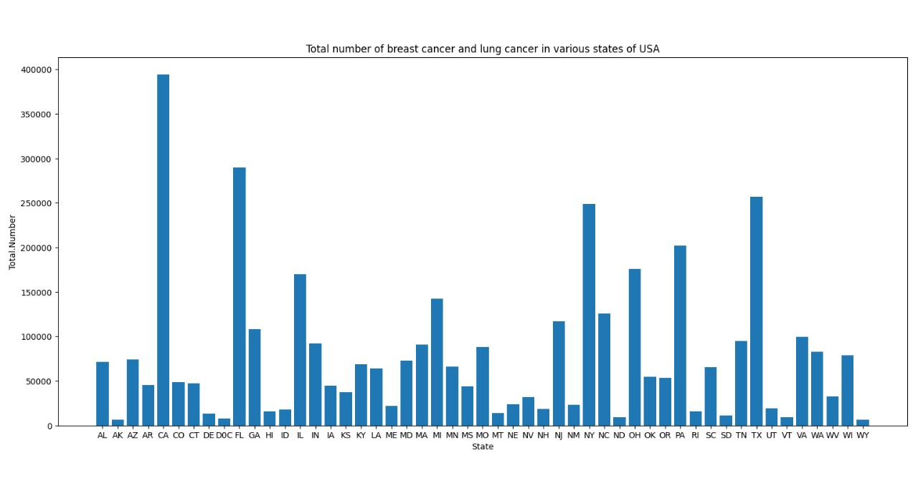

**Fig. 2.** Total number of breast cancer and lung cancer in USA (Generated by MatPlotLib)

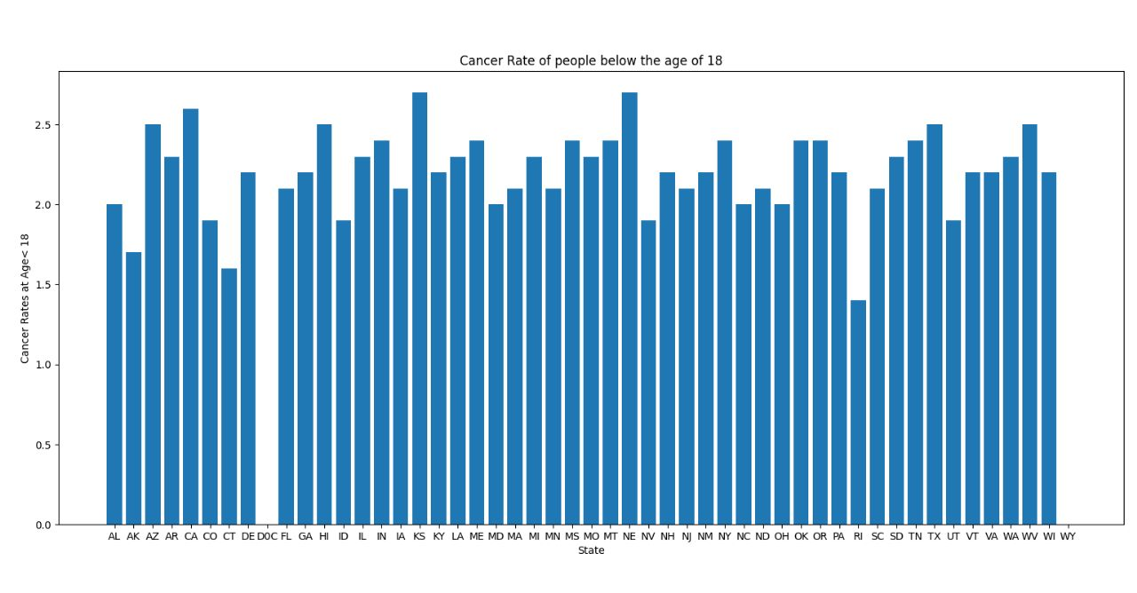

**Fig. 3.** Cancer rates of people below the age of 18 (Generated by MatPlotLib)

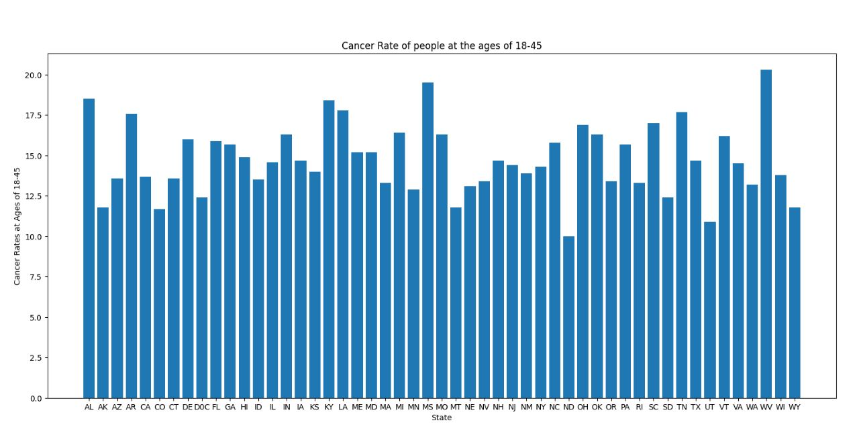

**Fig. 4.** Cancer rates of people at the ages of 18-45 (Generated by MatPlotLib)

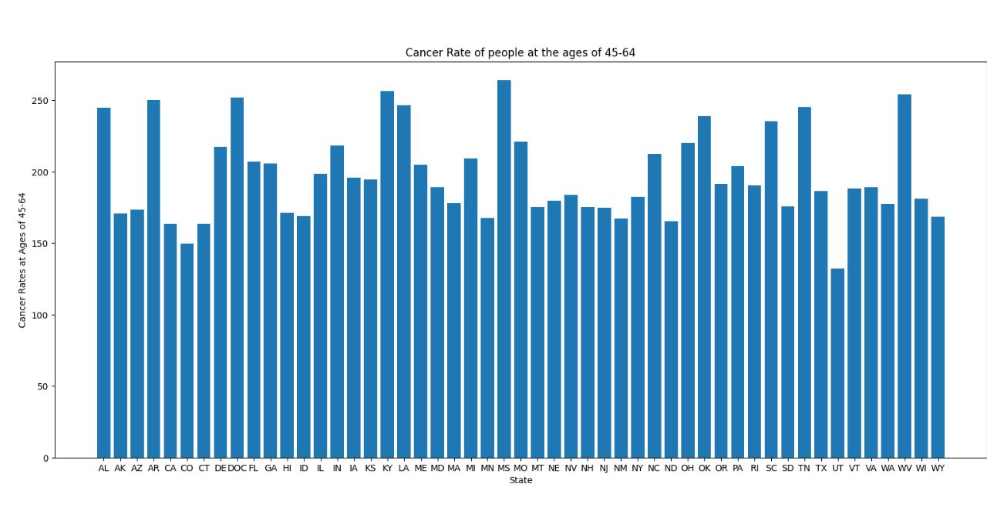

**Fig. 5.** Cancer rates of people at the ages of 45-64 (Generated by MatPlotLib)

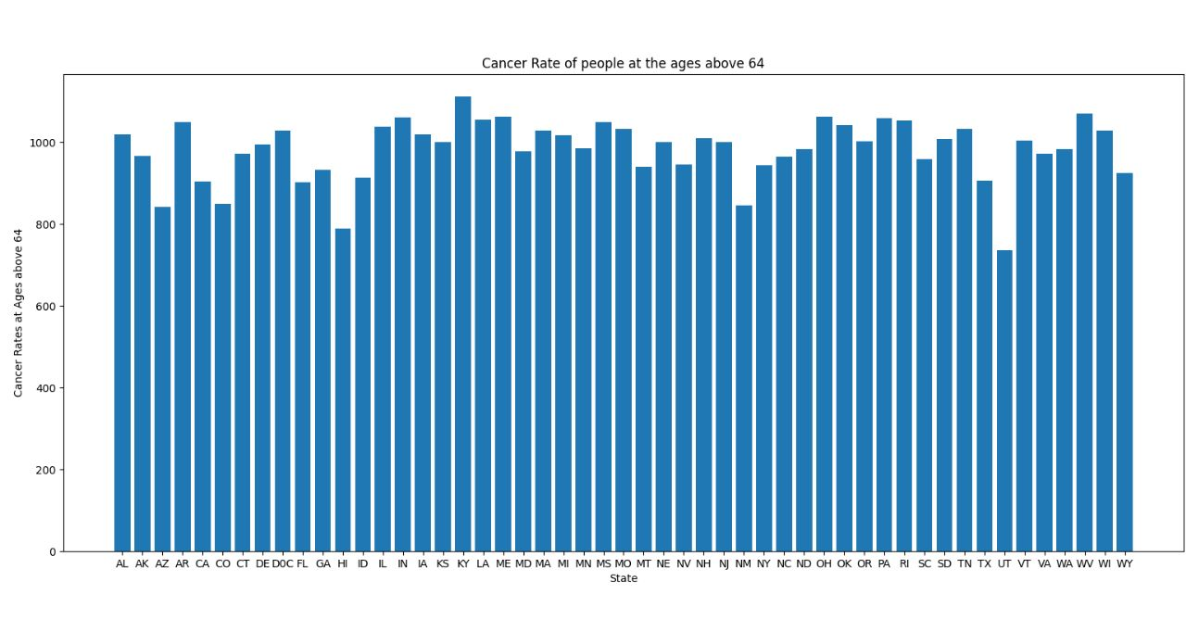

**Fig. 6.** Cancer rates of people above the age of 64 (Generated by MatPlotLib)

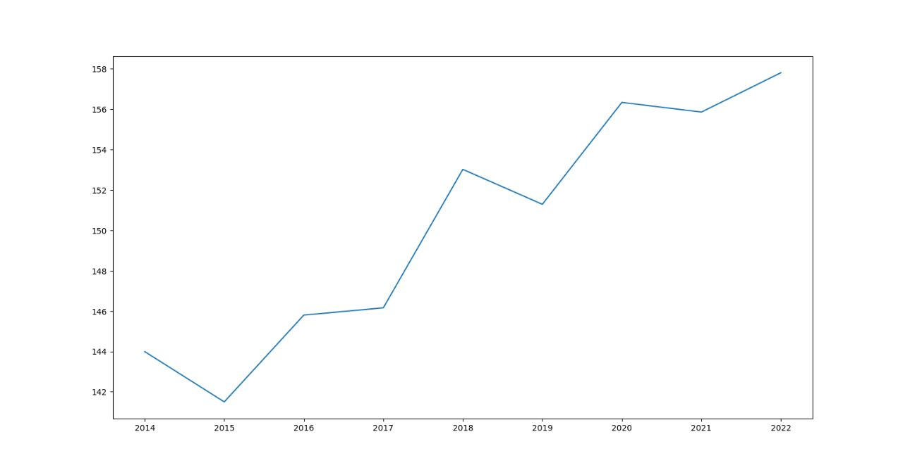

**Fig. 7.** A Graph showing average increase in Cancer Rates year by year(Generated by matplotlib)

**References**

Alshamlan, H. M., Badr, G. H., & Alohali, Y. A. (2015). Genetic Bee Colony (GBC) algorithm: A new gene selection method for microarray cancer classification. Computational Biology and Chemistry, 56, 49–60. https://doi.org/10.1016/j.compbiolchem.2015.03.001

Bevilacqua, V., Mastronardi, G., Menolascina, F., Paradiso, A., & Tommasi, S. (2006). Genetic Algorithms and Artificial Neural Networks in Microarray Data Analysis : a Distributed Approach. Engineering Letters, 13(3), 335–343.

Chen, H., Zhang, Y., & Gutman, I. (2016). A kernel-based clustering method for gene selection with gene expression data. Journal of Biomedical Informatics, 62, 12–20. https://doi.org/10.1016/j.jbi.2016.05.007

Chen, J., Li, K., Rong, H., Bilal, K., Yang, N., & Li, K. (2018). A disease diagnosis and treatment recommendation system based on big data mining and cloud computing. Information Sciences, 435, 124–149. https://doi.org/10.1016/j.ins.2018.01.001

Da Cruz, T. N., Da Cruz, T. M., & Pinheiro Dos Santos, W. (2018). Detection and classification of mammary lesions using artificial neural networks and morphological wavelets. IEEE Latin America Transactions, 16(3), 926–932. https://doi.org/10.1109/TLA.2018.8358675

Lamine, R. Ben, Jemaa, R. Ben, & Ben Amor, I. A. (2017). Graph Planning Based Composition for Adaptable Semantic Web Services. Procedia Computer Science, 112, 358–368. https://doi.org/10.1016/j.procs.2017.08.016

Ma, S. P., Fan, C. Y., Chuang, Y., Liu, I. H., & Lan, C. W. (2019). Graph-based and scenario-driven microservice analysis, retrieval, and testing. Future Generation Computer Systems, 100, 724–735. https://doi.org/10.1016/j.future.2019.05.048

Mathur, A., Sah, A., & Rawat, S. (2023). Evolution of Cloud Computing With Blockchain and IoT. In A. Taghipour (Ed.), Blockchain Applications in Cryptocurrency for Technological Evolution (pp. 14-32). IGI Global. https://doi.org/10.4018/978-1-6684-6247-8.ch002

Oluyide, O. M., Tapamo, J. R., & Viriri, S. (2018). Automatic lung segmentation based on Graph Cut using a distance-constrained energy. IET Computer Vision, 12(5), 609–615. https://doi.org/10.1049/iet-cvi.2017.0226

Rawat, S., & Kumar, R. (2020). Direct-Indirect Link Matrix: A Black Box Testing Technique for Component-Based Software. International Journal of Information Technology Project Management, 11(4), 56–69. https://doi.org/10.4018/IJITPM.2020100105

Rawat, S., & Sah, A. (2012). An approach to Enhance the software and services of Health care centre. 3(7), 126–137.

Rawat, S., & Sah, A. (2013a). An Approach to Integrate Heterogeneous Web Applications. International Journal of Computer Applications, 70(23), 7–12. https://doi.org/10.5120/12205-7639

Rawat, S., & Sah, A. (2013b). Prime and Essential Prime Implicants of Boolean Functions through Cubical Representation. International Journal of Computer Applications, 70(23), 1–6. https://doi.org/10.5120/12204-7638

Rodriguez-Mier, P., Pedrinaci, C., Lama, M., & Mucientes, M. (2016). An integrated semantic web service discovery and composition framework. IEEE Transactions on Services Computing, 9(4), 537–550. https://doi.org/10.1109/TSC.2015.2402679

Sah, A., Bhadula, S. J., Dumka, A., & Rawat, S. (2018). A software engineering perspective for development of enterprise applications. Handbook of Research on Contemporary Perspectives on Web-Based Systems, 1–23. https://doi.org/10.4018/978-1-5225-5384-7.ch001

Sah, A., Choudhury, T., Rawat, S., & Tripathi, A. (2020). A Proposed Gene Selection Approach for Disease Detection. Advances in Intelligent Systems and Computing, 1120, 199–206. https://doi.org/10.1007/978-981-15-2449-3_16

Sah, A., Dumka, A., & Rawat, S. (2018). Web technology systems integration using SOA and web services. Handbook of Research on Contemporary Perspectives on Web-Based Systems, 24–45. https://doi.org/10.4018/978-1-5225-5384-7.ch002

Sah, A., Rawat, S., Choudhury, T., & Dewangan, B. K. (2022). An Extensive Review of Web-Based Multi-Granularity Service Composition. International Journal of Web-Based Learning and Teaching Technologies, 17(4), 1–19. https://doi.org/10.4018/ijwltt.285570

Sah, A., Vanshika, Tyagi, S., Singla, P., & Rawat, S. (2023). Health Chain. In A. Taghipour (Ed.), Blockchain Applications in Cryptocurrency for Technological Evolution (pp. 160-172). IGI Global. https://doi.org/10.4018/978-1-6684-6247-8.ch010

Shandilya, S., & Chandankhede, C. (2018). Survey on recent cancer classification systems for cancer diagnosis. Proceedings of the 2017 International Conference on Wireless Communications, Signal Processing and Networking, WiSPNET 2017, 2018-Janua, 2590–2594. https://doi.org/10.1109/WiSPNET.2017.8300231